AN APPROACH TO EXAMINE THE EFFECT OF TAPER ANGLE AND THREADING ON PERIPROSTHETIC BONE REMODELING FROM BONE-ANCHORED AMPUTATION PROSTHESES

Anita Fung¹ and W. Brent Edwards²
¹Biomedical Engineering Program, University of Calgary, ²Faculty of Kinesiology, University of Calgary
afun@ucalgary.ca

INTRODUCTION
The most common problems experienced by transfemoral amputees using socket prostheses are soft tissue pain and a limited range of motion around the hip joint [1]. Recently, intraosseous transcutaneous amputation prostheses (ITAP) have been developed as an alternative to the standard socket prostheses for amputees. A current shortcoming of ITAP is the change in the local mechanical loading at the bone-implant interface leading to bone resorption. The clinical consequences of this bone loss are increased risks of bone fracture and implant loosening [2]. The purpose of this study was to develop a finite element modeling approach to examine the effect of ITAP fixture threading and taper angle on femoral bone remodeling.
METHODS
An intact femoral geometry was generated using Mimics software (Materialise, Leuven, Belgium) from CT scans obtained from the VAHKUM database [3]. Twelve ITAP (six threaded and six unthreaded) implants of varying taper angles were designed using SolidWorks (Waltham, MA). Implants were registered and aligned within the femoral diaphysis, and the implant-femur assembly was meshed with quadratic tetrahedral elements; elements at the bone-implant interface shared identical nodes to represent full osseointegration. Bone elements were assigned inhomogeneous linear-elastic material properties based on CT Hounsfield units. Implant material was modeled as titanium alloy Ti6Al4V (E=114 GPa, ν=0.3), which is commonly used for prostheses due to its superior strength and biocompatibility.
Boundary conditions and loads applied to the finite element models were taken from Tomaszewski et al. [4], which were linearly scaled to correspond to an individual with a mass of 70.1 kg and a height of 170 cm. All models were solved using ABAQUS Standard v6.1 (Providence, RI). Strain energy density was calculated for each implanted femur and compared to those of an intact femur.
RESULTS
Considerable energy was transferred to the ITAP (Figure 1). Consequently, the periprosthetic cortical bone in the implanted femur had a significantly lower strain energy density than that of the intact femur (Figure 1).
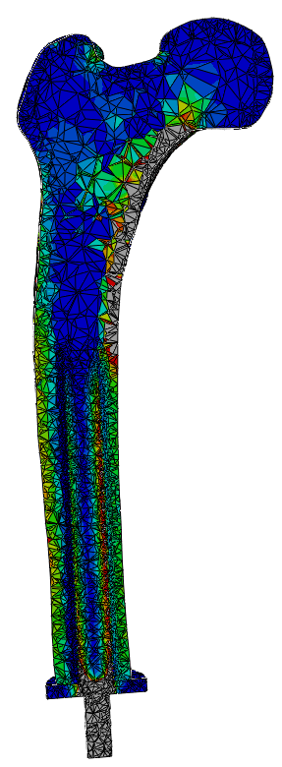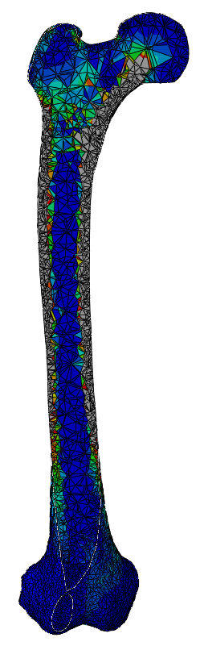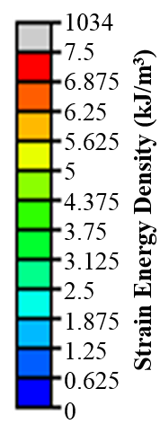
Figure 1. Strain energy density distribution of a femur implanted with a threaded, untapered fixture (left), and an intact femur (right).
DISCUSSION AND CONCLUSIONS
It is critical that implant geometry is optimized to decrease periprosthetic bone resorption and reduce the incidence of bone fracture and implant loosening. Changes in strain energy density following prosthetic implantation is a driving stimulus for bone remodeling, and our future work will incorporate adaptive bone remodeling algorithms into our simulations. such as [5]:
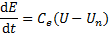
where E is the elastic modulus of the bone element, C_{e} is a constant that determines the rate of bone remodeling, U is the local strain energy density of the implanted femur, and U_{n} is the corresponding local strain energy density of the intact femur.
REFERENCES
- Hagberg & Brånemark. Prosthet Orthot Int. 25:186-94, 2001.
- Xu & Robinson. Ann Biomed Eng. 36:435-43, 2008.
- http://www.ulb.ac.be//project/vakhum/
- Tomaszewski P K, et al. Ann Biomed Eng. 38:2418-27, 2010.
- Huiskes R, et al. J Biomech. 20:1135-50, 1987.

