Cartilage Boundary Lubricating Ability of PRG4 (Lubricin) Monomers and Multimers with Hyaluronan

Janna Haladuick¹, Saleem Abubacker², Tannin Schmidt^{1,2,3}
¹Faculty of Kinesiology, ²Biomedical Engineering Program, ³Schulich School of Engineering, University of Calgary
jkhaladu@ucalgary.ca

INTRODUCTION
Proteoglycan 4 (PRG4), or lubricin, is a glycoprotein that exists in synovial fluid (SF) as monomeric and disulfide-bonded multimeric forms [1,2]. PRG4 functions as a critical boundary lubricant on the surface of articular cartilage [1,3]. Hyaluronan (HA) is another lubricant that lubricates at a cartilage-cartilage interface alone, and synergistically with PRG4 to reduce friction levels near that of SF [4]. Previously PRG4-multimers (PRG4-multi) have been shown to lubricate considerably better than PRG4 monomers (PRG4-mono) using an in vitro cartilage-on-cartilage friction testing system [5]. However, it is unknown if the difference in structure of PRG4-multi/-mono affects the synergism with HA. Therefore, the objective of this study was to evaluate the cartilage boundary lubricating ability of PRG4-multi & PRG4-mono with HA.

METHODS
Samples: PRG4 was purified from media conditioned by mature bovine cartilage explants [4]. PRG4 multi-mono was prepared via size exclusion chromatography [5]. HA (1.5MDa) was obtained from Lifecore Biomedical.
Cartilage boundary lubrication: Lubricants of interest were assessed using a previously described in vitro cartilage-cartilage friction test [6]. Briefly, bovine osteochondral samples (n=8) were incubated with test lubricants overnight, compressed by 18%, allowed to stress relax then rotated at an effective velocity of 0.3 mm/s with pre-sliding durations (Tps) of 1200, 120, 12, and 1.2s. Phosphate buffered saline (PBS) and bovine SF served as negative and positive controls, respectively. All samples were prepared at a physiological concentration [4]; PRG4 at 450 μg/mL and HA at 3.33 mg/mL, in PBS. Test sequence: PBS, PRG4-mono+HA, PRG4-multi+HA, PRG4+HA, SF. Static (μ_{static,Neq}) and kinetic (<μ_{kinetic,Neq}>) friction coefficients were calculated [4,6]. ANOVA was used to assess the effect of lubricant and Tps, as a repeated factor, on μ_{static,Neq} and <μ_{kinetic,Neq}>, with Tukey post-hoc on <μ_{kinetic,Neq}> at Tps=1.2s.

RESULTS
Cartilage boundary lubrication: PRG4-mono/-multi+HA, functioned as effective friction-reducing cartilage boundary lubricants. However, they did not lubricate as well as PRG4+HA or SF. μ_{static,Neq} values increased with Tps; they were highest in PBS and lowest in SF, with PRG4-mono+HA, PRG4-multi+HA, and PRG4+HA being intermediate (Fig.1A). For clarity, <μ_{kinetic,Neq}> values at Tps=1.2s are shown since values at Tps=1.2s were within 13.0±2.7% of those at Tps=1200s. <μ_{kinetic,Neq}> values for PRG4-mono+HA and PRG4-multi+HA were similar (p=0.96). PRG4+HA and SF were similar (p=0.53). All other combinations were significantly different from each other (p<0.05) (Fig. 1B).

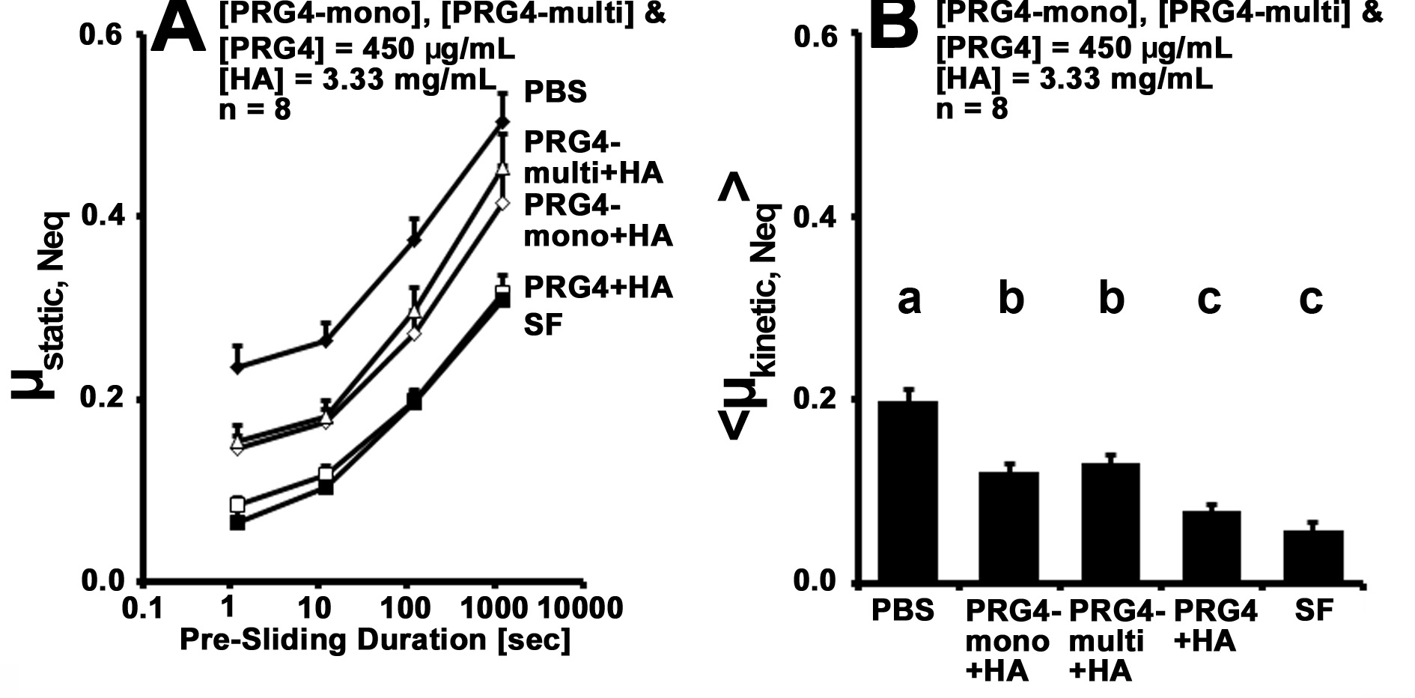Figure 1: μ_{static,Neq} (A) and <μ_{kinetic,Neq}> (B) for PBS, PRG4-multi+HA, PRG4-mono+HA, PRG4+HA, and SF (n=8). Mean ± SEM. Different letters denote significance (p<0.05).
DISCUSSION AND CONCLUSIONS
Previous studies have shown that PRG4-multi lubricates better than PRG4-mono [5]. However the results from this study show that PRG4-mono/-multi with HA lubricate in a similar manner. Interestingly, PRG4+HA lubricates better than PRG4-mono/-multi+HA, and close to that of SF. These differences could be due to a potential PRG4+HA “link molecule” [7] being purified from the PRG4-mono/-multi preparations.
REFERENCES
- Swann D, et al. J Biol Chem. 256: 5921-5925, 1981
- Schmidt T, et al. Bioch Biophys Acta. 5: 375-384, 2009
- Jay G. Curr Opin Ortho 5: 355-359, 2004
- Schmidt T, et al. Arthritis Rheumatol. 56: 882-891, 2007
- Abubacker S, et al. Trans ORS. 2013
- Schmidt T, et al. Osteoarth Cart. 15: 35-47, 2007
- Flannery, et al. Trans ORS. 2010

