ABNORMAL PASSIVE FORCES IN FROG TIBIALIS ANTERIOR MUSCLES
Alex Li², Brandon Hisey¹, Andrew Sawatsky¹, Walter Herzog^{1,2}
¹Human Performance Lab, University of Calgary, ²Biomedical Engineering Program, University of Calgary
aleli@ucalgary.ca

INTRODUCTION
Typically in force-length relationships of skeletal muscle, the passive forces are much lower than the active forces. These results have been shown in both single fiber experiments and whole muscle experiments [1]. However, abnormally high passive forces were noticed in a pilot study done with the whole tibialis anterior (TA) in the frog, rana pipiens. Surprisingly, single fiber experiments of the same muscle and species have shown a standard force-length relationship with low passive force.

Thus, the purpose of this study was to verify the observation of extremely high passive forces made previously and, if true, investigate the range of muscle lengths in which these high pasive forces occur. Possible functional reasons for this phenomenon will be discussed.

METHODS
The TA and sciatic nerve of three frogs were isolated with surgical techniques. The attached tarsal bone was clamped to a load cell and the knee was pinned. The muscle was then stretched to various lengths and isometrically contracted via nerve stimulation with a platinum hook. A Short rest was given between trials. Whole muscle biopsies were taken and prepared for analysis of sarcomere length within the normal range of motion.
The range of muscle lengths in which the animal normally functions was analysed by configuring knee and ankle joint angles to values that were identified for swimming and jumping. [2].
RESULTS
All subjects showed very large passive forces on the ascending limb of the force-length relationship (Figure 1). At long muscle lengths, passive forces were up to six times as high as the corresponding active forces.
The functional range of muscle lengths for jumping and swimming is 87-95% and 91%-96%, respectivelyof the maximum in vivo muscle length. The shortest in vivo muscle length is about 77% of its maximal in vivo length.
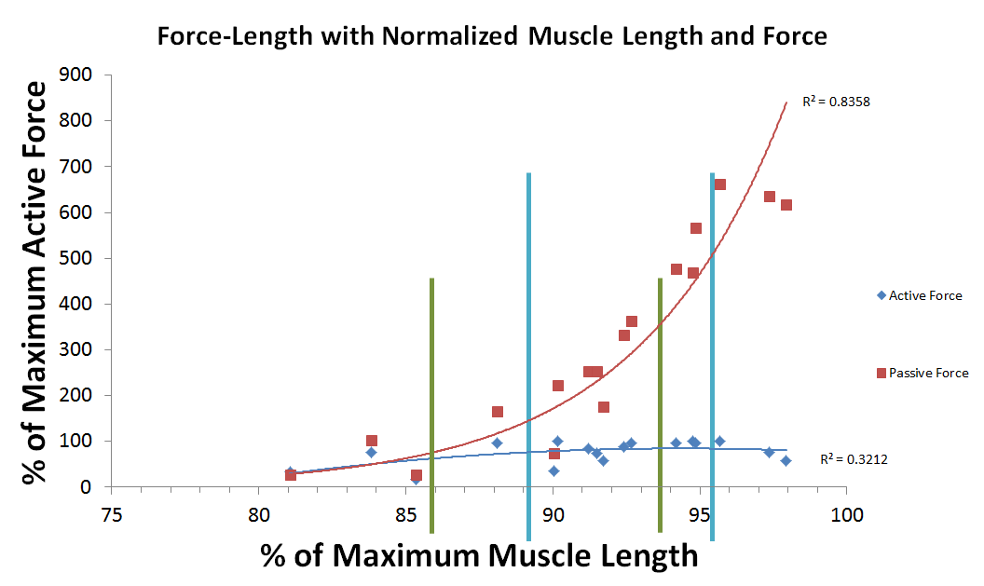Figure 1: Active/Passive force-length data. Muscle length normalized to maximum in vivo length and forces normalized to maximal active isometric force. Blue and green lines exhibit the approximate range for jumping and swimming.
DISCUSSION AND CONCLUSIONS
It is likely that the high passive forces observed in the frog TA come from the extracellular matrix, as earlier studies with single TA fibers show low passive force [3]. These high passive forces found for the entire muscle have implications for the function of the muscle during every day activities, such as swimming and jumping.

It has been demonstrated that frogs produce extremely high muscle power output during jumping [4]. They achieve these high powers by using a catapult mechanism through the plantaris tendon [5]. High passive forces in the TA would be a natural development to counterbalance plantaris forces as the TA is the antagonist muscle to the plantaris.

It is also possible that the high passive forces in the TA are used during frog swimming. Since frogs have large webbed feet, a high passive force in the TA allows frogs to use their feet like human swimmers use passive fins at to increase the speed and decrease the energy expenditure of swimming.
REFERENCES
- Rassier DE, et al. J Appl Physiol. 86:1445-1457, 1999.
- Peters SE, et al. J Morphol. 230:1-6.1996
- Bagni MA, et al. J Physio. 401:581-595,1988
- Peplowski & Marsh. J Exp Biol. 200:2861-2870,1997
- Astley & Roberts. Biol Lett. 8:386-389,2011

