Effect of counterface on Cartilage boundary lubricating ability by hyaluronan and proteoglycan 4: cartilage-cartilage vs cartilage-glass

Allison McPeak¹, Saleem Abubacker², Tannin Schmidt^{1,3}
¹Faculty of Kinesiology, ²Biomedical Engineering Program, ³Schulich School of Engineering, University of Calgary
aemcpeak@ucalgary.ca

INTRODUCTION
Proteoglycan 4 (PRG4), also known as lubricin, is a mucin-like glycoprotein found in synovial fluid (SF) [1]. Hyaluronan (HA) is another constituent of SF that works synergistically with PRG4 to promote joint lubrication required for joint health [2]. Current in vitro friction tests used to analyze these lubricants have found similar trends but varying friction coefficient (μ) magnitudes. These effects may be attributed to different testing protocols, and in particular the various interfaces [3,4,5,6,7,8]. Previous studies have used cartilage-cartilage [7,8] and cartilage-glass [6] friction tests to assess SF lubricants. However, few studies have examined the friction reducing ability of SF lubricants at various velocities and different interfaces. The objective of this study was to determine HA and PRG4’s lubricating ability at cartilage-glass and cartilage-cartilage biointerfaces at various velocities.

METHODS
HA (1.5 MDa, Lifecore Biomedical) was prepared at 3.3 mg/mL with phosphate buffered saline (PBS) [9]. PRG4 was purified from media conditioned bovine cartilage explants, and prepared at 450 μg/mL in PBS [9]. Two sets of tests were conducted using a modified boundary lubrication test protocol [7]. For cartilage-glass, a 6mm radius glass piece, with a root mean square surface roughness of 6.061±0.7554 nm, acted as the base core with a cartilage annuli [7]. Three lubricants were tested over three days, PBS (n=8), HA or PRG4 (n=4), and SF (n=8). Cartilage-cartilage underwent the same test sequence. Both sets of samples underwent the same testing protocol; samples were compressed to 18% of the total cartilage thickness with a 40 minute stress relaxation [9]. Samples were then rotated at effective sliding velocities of 10, 3, 1, 0.3, 0.1, and 0.01 mm/s with a 120s pre-sliding duration. Kinetic μ was calculated with instantaneous (<μ_{kinetic}>) load values. A two-factor ANOVA was used to determine effects of lubricant and velocity, with Tukey post-hoc testing.
RESULTS
At the cartilage-glass interface (Fig. 1A), <μ_{kinetic}> varied with test lubricant and velocity (p<0.001), with no interaction (p=0.78). All lubricants were significantly different from each other (p<0.001), except for PBS/HA (p=0.65) and PRG4/SF (p=0.72). Velocities were significantly different from each other when comparing 0.01 mm/s to all other speeds (p<0.02). At the cartilage-cartilage interface (Fig. 1B), <μ_{kinetic}> varied with test lubricant and velocity (p<0.01), with no interaction (p=0.82). All lubricants were significantly different from each other (p<0.01), except for HA/SF (p=0.07) and HA/PRG4 (p=0.35). Velocity was only significantly different at 0.01mm/s when compared to 3 and 10 mm/s (p<0.028).
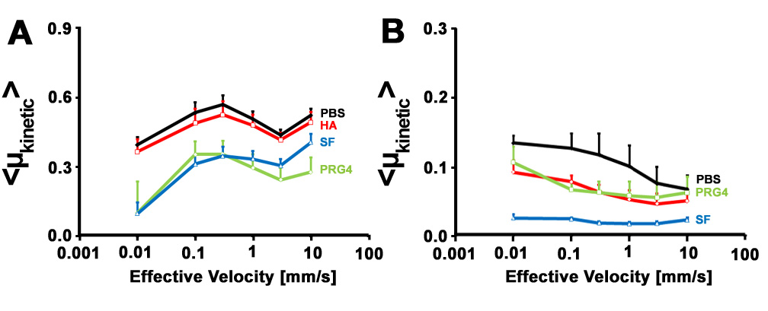Figure 1: Average kinetic coefficient of friction <μ_{kinetic}> of (A) cartilage-glass, and (B) cartilage-cartilage.
DISCUSSION AND CONCLUSIONS
These results indicate that different articulating interfaces can result in different trends of <μ_{kinetic}>, and also affect the magnitude of the value. This agrees with previous research; showing that stiff and impermeable surfaces versus hydrated and permeable surfaces results in different <μ_{kinetic}> [3]. This data illustrates that HA is indeed a cartilage boundary lubricant and reduces friction at the cartilage-cartilage interface, but not at a cartilage-glass set up. Overall, different test systems are suitable for characterizing lubrication properties, but direct <μ_{kinetic}> values should not be compared.
REFERENCES
- Swann D, et al. J Biol Chem. 256: 5921-5925, 1981
- Teeple E, et al. AM J Sports Med. 39: 164-172, 2011
- Dunn A, et al. Tribol Lett. 54: 59-66, 2014
- Jay G, et al. Arthritis Rheumatol. 11: 3662-3669, 2007
- Jay G, et al. Connect Tissue Res. 28: 71-88, 1992
- Gleghorn J, et al. J Biomech. 41: 1910-1918, 2008
- Schmidt T, et al. Osteoarth. Cartilage. 15: 35-47, 2007
- Davis W, et al. J Biomech Eng. 101: 185-192, 1978
- Schmidt T, et al. Arthritis Rheumatol. 56: 882-891, 2007

