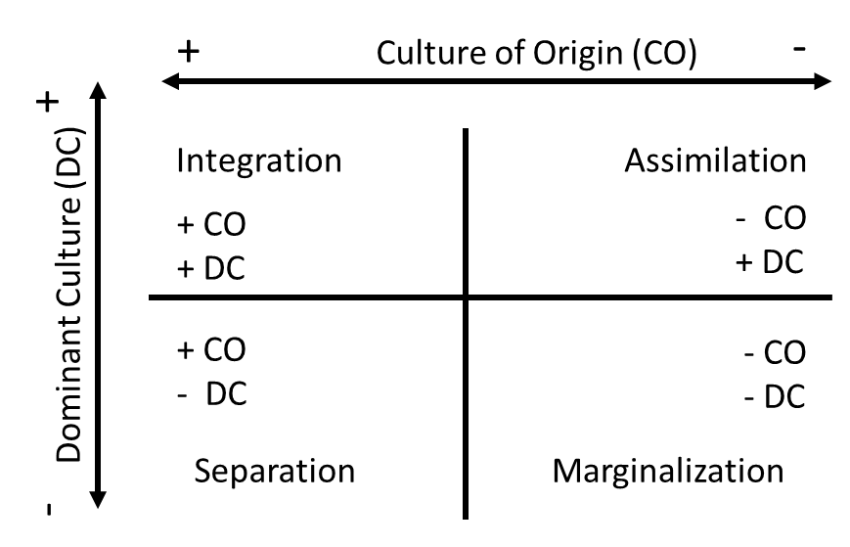
Figure 1. Depiction of the two-dimensional organization of the four quadrants in the Eco-Cultural Model. Integration (++) represents positive attitudes towards culture of origin (CO) and Dominant Culture (DC). Assimilation (-+) represents negative attitudes negative attitudes towards CO and positive towards DC. Separation (+-) represents positive attitudes towards CO and negative towards DC. Marginalization (--) represents negative attitudes towards CO and DC.

