Valuing Alberta’s renewable electricity program
Sara Hastings-Simon and Blake Shaffer
When Alberta’s government launched the Renewable Electricity Program (REP) in 2017, many feared it would result in yet another costly subsidy for renewable power. With a little over a year since first generation, we look back on how the REP contracts have fared so far. It may come as a surprise then that the government is actually making money on them.
In 2017-2018, the Alberta Electric System Operator (AESO), under the direction of the Alberta Government, awarded contracts for new renewable generation capacity under the competitive Renewable Electricity Program (REP). Under this program, developers competed against one another in a competitive auction, with the lowest cost offers receiving contracts.
Designed to bring on new renewable generation capacity, REP contracted renewables within the deregulated electricity market using a “contract for differences (CFD)” approach. With a CFD, the buyer (in this case the AESO, on behalf of the government) and seller (the renewable project) agree on a price for the renewable energy yet the project sells its electricity to Alberta’s power pool. If the project receives a pool price below the agreed CFD level, government makes up the difference; but if the project makes more in the market, it pays back the excess to the government (hence “contract for differences”). It works out to fixed price certainty for the project with the auction design ensuring the government receives a competitive price.
In the end, roughly 1800 MW of wind capacity was contracted under the program at prices in the range of $31-43 per megawatt-hour (3 to 4 cents per kilowatt-hour), before all future REP rounds were cancelled by the incoming UCP government.
With the first three of these projects—Whitla, Riverside, and Castle Rock Ridge 2, all winners in Round 1 of the REP—now in service for a little over a year, we do the math on how the contracts have fared so far.
First, a caveat. The only publicly available data is the average price in each of the three REP rounds, not the individual facility contracts. With that in mind, we use the average price for Round 1 ($37 per MWh) as our baseline contract cost.
There are two components of value the government is contracting for. The first is energy value. This is the price earned in the market by these facilities, weighted by when they are generating. Wind tends to blow in the evening, resulting in slightly lower than average prices. For these three facilities, the generation-weighted price since inception is $38.35 per MWh. The contracts are “in-the-money”. Based on their cumulative generation of 1.5 million MWh to-date, cash has flowed from the companies to the government to the tune of roughly $2 million.
But value doesn’t stop there. By agreeing to REP contracts, the wind farms surrendered the right to receive carbon offsets or emissions credits under Alberta’s then-CCIR, now-TIER, emissions regulation. This needs to be included in the calculation because in the absence of REP, government would provides these credits to the projects, which is a transfer of economic value. By not doing so, the government avoids this cost.
Currently, offsets are valued at $30 per tonne multiplied by 0.53 tonnes per MWh (the prescribed emissions factor of a mix of natural gas and coal plants). The carbon offset value is thus currently worth $15.90 per MWh and will rise with the rising carbon price. With the contracts being in-the-money on energy alone, Alberta is getting these emissions reductions for free (negative, actually!).
In total, the value of these three wind facilities to-date has been a little over $54 per MWh versus a contract price of only $37, for an inception-to-date gain to the government of $26 million.¹
Yes, that’s not a typo: the government made a gain on these renewable contracts in exchange for the revenue certainty they provided.
Of course, this is but a snapshot from September 2019 (first generation) to today (mid-February 2021). The REP contracts have 18 years remaining, and some have yet to commence. The COVID-driven drop in demand for electricity this past year has brought power demand and prices down, so future years could be even better for the REP contracts. If wind build out is significant in the future, the opposite could be true and realized prices for wind could drop. Ultimately, time will tell, but the contracts are off to a good start.

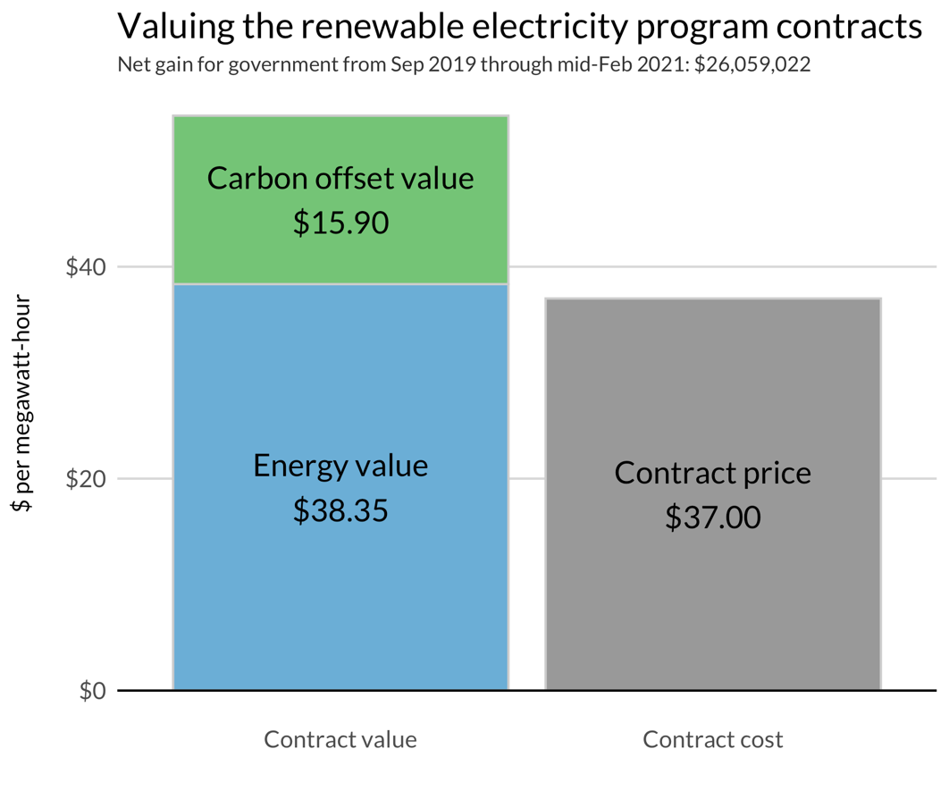

Given this information, what conclusions can we take away from the analysis?
First, history has shown many government contracts for renewables haven’t worked out so well; the success of the REP to date, with government coming out ahead on the contracts, shows this needn’t be the case, particularly as renewable energy costs have fallen over time.
With so much apprehension based on historically poor performance of renewable contracts in other jurisdictions, the AESO ought to produce an annual report of REP contract performance – good or bad. Informing the public can help update priors based on outdated information. More transparency always helps.
Second, that companies were willing to sell for $37 what ultimately was worth $54 (so far) shows that government policy can add value by overcoming barriers to development, in this case de-risking revenue in order to finance their development. Good policy design is key to realizing benefits and in this case the auction drove competition between developers to deliver lower prices. In addition the contract for differences approach ensures that any upside benefit accrues to the public in exchange for the de-risking. This is a win-win for consumers and developers alike, as the former get cheap power, and the latter get adequate—and less risky—returns.
FIGURE 1 – RENEWABLE ELECTRICITY PROGRAM CONTRACT VALUE VS COST
Finally, while REP may be gone under the UCP, these values show us the economics of renewables mean they are here to stay. For renewable energy developers, finding corporate PPAs to help manage the volatility of electricity market prices will now be the name of the game, helped by the market for renewables created with the government program. Expect continued growth of renewable energy in Alberta’s power mix even without future government contracts.

FOOTNOTES:
- The publicly available information regarding REP contracts details include the weighted average, maximum, and minimum contract price for each REP round. The above calculation (resulting in an $26.0 million gain) uses the weighted average price for all facilities. To stress test this value, we use the maximum price ($43.30) for Whitla, the facility delivering the most generation to-date, and a lower price for the other two facilities to maintain the $37 weighted price. This results in a gain of $20.1 million.

REFERENCES:
- Alberta Electric System Operator (AESO). “Hourly Metered Volumes and Pool Price and AIL data 2008 to 2021.” https://www.aeso.ca/market/market-and-system-reporting/data-requests/hourly-metered-volumes-and-pool-price-and-ail-data-2008-to-2021/.
- Alberta Electric System Operator (AESO). “REP Results.” https://www.aeso.ca/market/renewable-electricity-program/rep-results/.

